**T5L Screen ModBus Communication**

1: The ModBus protocol is executed on the serial port 4 of the T5L screen.

2: ModBus of T5L screen can be configured with master or slave.

3: The protocol is compatible with Ascii and RTU formats (ascii is not currently supported).

4: Instruction format is divided into standard format and clock format.

5: When configured as a host, the command has the function of automatic reissue.

6: There are 5 ways to trigger sending when configured as a host.

7: The maximum read and write data length is 64 words (128 bytes).

8: The maximum number of instructions is 255.

9: Support commands 0X01,0X02,0X03,0X04,0X05,0X06,0X10.

10: When acting as a master, the data configured in the 0x10 command will be automatically sent (initialize the slave) after power-on.

11: The 70-word variable address from the last instruction of the configured file No. 22 is occupied.

12: Timer T1 is occupied.

13: The seventh page of the register is occupied.

**The definition of the system variable interface of DWIN screen ModBus communication**

The system variable interface definition occupies 16 bytes starting from 0x0088.

0x0088H: 0x5A = Start configuration once.

0x0088L: 0xA5=Enable (enabled by default) Modbus, others=Not enabled.

0x0089: Edit the start (word) address of the instruction in file No. 22 (default 0xE000).

0x008AH: Edit the number of instructions in file No. 22, each with 8 characters (255 by default).

0x008AL: 0x00=Configure as master , RTU data format (default 0X00).

0x01=Configure as master , ascii data format.

0x02=Configure as a master (RTU), the slave responds with a clock in the data.

0x03=Configure as a master (ascii), and the slave response data includes a clock.

0x04=Configure as a slave, RTU data format.

0x05=Configure as a slave, ascii data format.

0x008BH: The number of times this command is reissued when the slave does not respond or responds incorrectly (5 times by default).

0x008BL: The delay time from the execution of this command to the sending of the next one (default 100ms).

0x008CH: ID when configured as a slave (default 01).

0x008CL: Check configuration (default 40=serial port 4, 8N1).

0x008D: Baud rate configuration (default 2688, 25804800/9600=2688=0x0A80).  
0x008EH: The fault code of the communication process.

0x008EL: When configured as a host, the serial number of the currently executed command in file 22

0x008F: Reserve

**Example for System variable interface configuration**

EG: 5A,A5,E000,FF, 00,05,64,01,40,0A80, 00, 00, 00, 00.

0x0088H=0x5A :0x5A=Enable Modbus configuration, reset after configuration.

0x0088L=0xA5 : 0XA5=Enable Modbus communication

0x0089=0xE000 :The start (word) address of the first instruction in file 22=0xE000

0x008AH=0xFF :Edited 255 instructions (1-255) in file 22.

0x008AL=0x00 :0X00= Configure as host, RTU data format (0-5).

0x008BH=0x05 :The slave does not respond or the response received error, the master reissues the current command, the upper limit of reissue is 5 times (0-255).

0x008BL=0x64 :The delay time between instructions=0x64=100mS (0-255).

0x008CH=0x01 :The assigned communication ID when configured as a slave=0x01 (0x01-0x7F).

0x008CL=0x40 :0x00=8N1, 0x01= 8E1, 0X02=8O1,0X03=8N2.

0x008D=0x0A80 :25804800/(0A80)2688=9600 baud rate (T5L).

0x008EH=0x00 :Error code during communication (read only).

0x008EL=0x00 : When configured as the master, the serial number of the currently executed command in file 22 will be updated after the slave correctly answers (read-only).

0x008F : Reserve

**Example of editing configuration format of instructions in file 22**

EG: 5A 01 03 06 02 01 00 02 10 00 00 01

D0: 0x5A=This instruction is executed, others=This instruction is not executed.

D1: The ID number of the slave to be operated (01H).

D2: Command (03H) (0x01,0x02,0x03,0x04,0x05,0x06,0x10).

D3: The length of the operation data of this instruction (06H) (03H, 04H, 06H, 10H are calculated in words).

D4: Receiving timeout time (2mS). (2~255)

D5: Trigger command execution sending mode (0-4)

0x00=Unconditional execution.

0x01=Execute under the page specified by D6.D7.

0x02=Execute when the key value specified by D6.D7 is non-zero, the key value will be cleared after the instruction is executed.

0X03=In the 0x06 instruction, when the value of the variable pointed to by D8.D9 is not zero, it will be sent automatically.

After the communication is completed, clear the value of the variable specified by D8.D9.

0x04=In the 0x05,0x06;0x10 instruction, it will be sent automatically when the specified variable D8.D9 changes.

D6.D7: When D5=0, no configuration is required.

When D5=1, it is configured as the page number (0002).

When D5=2, it is configured as the key address that triggers the sending.

When D5=3, no configuration is required.

When D5=4, no configuration is required.

D8.D9: This instruction is used to manipulate the source variable address or start address (1000H) of the data allocated in the DGUS screen.

D10.D11: The slave address table (0001H) operated by this instruction.

D12.D13.D14.D15: Undefined.

This command is to read the data of 6 consecutive words in the point table starting from 0x0001 of the slave (id=0x01) when the screen is the master, and display it at the address 0x1000_0x1005 of the screen.

**T5L screen bit definition area 1 (256bit display area)**

0x0100

|  |  |  |  |  |  |  |  |  |  |  |  |  |  |  |  |
| --- | --- | --- | --- | --- | --- | --- | --- | --- | --- | --- | --- | --- | --- | --- | --- |
| 015 | 014 | 013 | 012 | 011 | 010 | 009 | 008 | 007 | 006 | 005 | 004 | 003 | 002 | 001 | 000 |

0x0101

|  |  |  |  |  |  |  |  |  |  |  |  |  |  |  |  |
| --- | --- | --- | --- | --- | --- | --- | --- | --- | --- | --- | --- | --- | --- | --- | --- |
| 031 | 030 | 029 | 028 | 027 | 026 | 025 | 024 | 023 | 022 | 021 | 020 | 019 | 018 | 017 | 016 |

0x0102

|  |  |  |  |  |  |  |  |  |  |  |  |  |  |  |  |
| --- | --- | --- | --- | --- | --- | --- | --- | --- | --- | --- | --- | --- | --- | --- | --- |
| 047 | 046 | 045 | 044 | 043 | 042 | 041 | 040 | 039 | 038 | 037 | 036 | 035 | 034 | 033 | 032 |

0x0103

|  |  |  |  |  |  |  |  |  |  |  |  |  |  |  |  |
| --- | --- | --- | --- | --- | --- | --- | --- | --- | --- | --- | --- | --- | --- | --- | --- |
| 063 | 062 | 061 | 060 | 059 | 058 | 057 | 056 | 055 | 054 | 053 | 052 | 051 | 050 | 049 | 048 |

0x0104

|  |  |  |  |  |  |  |  |  |  |  |  |  |  |  |  |
| --- | --- | --- | --- | --- | --- | --- | --- | --- | --- | --- | --- | --- | --- | --- | --- |
| 079 | 078 | 077 | 076 | 075 | 074 | 073 | 072 | 071 | 070 | 069 | 068 | 067 | 066 | 065 | 064 |

0x0105

|  |  |  |  |  |  |  |  |  |  |  |  |  |  |  |  |
| --- | --- | --- | --- | --- | --- | --- | --- | --- | --- | --- | --- | --- | --- | --- | --- |
| 095 | 094 | 093 | 092 | 091 | 090 | 089 | 088 | 087 | 086 | 085 | 084 | 083 | 082 | 081 | 080 |

0x0106

|  |  |  |  |  |  |  |  |  |  |  |  |  |  |  |  |
| --- | --- | --- | --- | --- | --- | --- | --- | --- | --- | --- | --- | --- | --- | --- | --- |
| 111 | 110 | 109 | 108 | 107 | 106 | 105 | 104 | 103 | 102 | 101 | 100 | 099 | 098 | 097 | 096 |

0x0107

|  |  |  |  |  |  |  |  |  |  |  |  |  |  |  |  |
| --- | --- | --- | --- | --- | --- | --- | --- | --- | --- | --- | --- | --- | --- | --- | --- |
| 127 | 126 | 125 | 124 | 123 | 122 | 121 | 120 | 119 | 118 | 117 | 116 | 115 | 114 | 113 | 112 |

0x0108

|  |  |  |  |  |  |  |  |  |  |  |  |  |  |  |  |
| --- | --- | --- | --- | --- | --- | --- | --- | --- | --- | --- | --- | --- | --- | --- | --- |
| 143 | 142 | 141 | 140 | 139 | 138 | 137 | 136 | 135 | 134 | 133 | 132 | 131 | 130 | 129 | 128 |

0x0109

|  |  |  |  |  |  |  |  |  |  |  |  |  |  |  |  |
| --- | --- | --- | --- | --- | --- | --- | --- | --- | --- | --- | --- | --- | --- | --- | --- |
| 159 | 158 | 157 | 156 | 155 | 154 | 153 | 152 | 151 | 150 | 149 | 148 | 147 | 146 | 145 | 144 |

0x010A

|  |  |  |  |  |  |  |  |  |  |  |  |  |  |  |  |
| --- | --- | --- | --- | --- | --- | --- | --- | --- | --- | --- | --- | --- | --- | --- | --- |
| 175 | 174 | 173 | 172 | 171 | 170 | 169 | 168 | 167 | 166 | 165 | 164 | 163 | 162 | 161 | 160 |

0x010B

|  |  |  |  |  |  |  |  |  |  |  |  |  |  |  |  |
| --- | --- | --- | --- | --- | --- | --- | --- | --- | --- | --- | --- | --- | --- | --- | --- |
| 191 | 190 | 189 | 188 | 187 | 186 | 185 | 184 | 183 | 182 | 181 | 180 | 179 | 178 | 177 | 176 |

0x010C

|  |  |  |  |  |  |  |  |  |  |  |  |  |  |  |  |
| --- | --- | --- | --- | --- | --- | --- | --- | --- | --- | --- | --- | --- | --- | --- | --- |
| 207 | 206 | 205 | 204 | 203 | 202 | 201 | 200 | 199 | 198 | 197 | 196 | 195 | 194 | 193 | 192 |

0x010D

|  |  |  |  |  |  |  |  |  |  |  |  |  |  |  |  |
| --- | --- | --- | --- | --- | --- | --- | --- | --- | --- | --- | --- | --- | --- | --- | --- |
| 223 | 222 | 221 | 220 | 219 | 218 | 217 | 216 | 215 | 214 | 213 | 212 | 211 | 210 | 209 | 208 |

0x010E

|  |  |  |  |  |  |  |  |  |  |  |  |  |  |  |  |
| --- | --- | --- | --- | --- | --- | --- | --- | --- | --- | --- | --- | --- | --- | --- | --- |
| 239 | 238 | 237 | 236 | 235 | 234 | 233 | 232 | 231 | 230 | 229 | 228 | 227 | 226 | 225 | 224 |

0x010F

|  |  |  |  |  |  |  |  |  |  |  |  |  |  |  |  |
| --- | --- | --- | --- | --- | --- | --- | --- | --- | --- | --- | --- | --- | --- | --- | --- |
| 255 | 254 | 253 | 252 | 251 | 250 | 249 | 248 | 247 | 246 | 245 | 244 | 243 | 242 | 241 | 240 |

Usually cooperate with the display control of DWIN screen, bit variable icon control.

**T5L screen bit definition area 2 (256bit key area)**

0x0110

|  |  |  |  |  |  |  |  |  |  |  |  |  |  |  |  |
| --- | --- | --- | --- | --- | --- | --- | --- | --- | --- | --- | --- | --- | --- | --- | --- |
| 015 | 014 | 013 | 012 | 011 | 010 | 009 | 008 | 007 | 006 | 005 | 004 | 003 | 002 | 001 | 000 |

0x0111

|  |  |  |  |  |  |  |  |  |  |  |  |  |  |  |  |
| --- | --- | --- | --- | --- | --- | --- | --- | --- | --- | --- | --- | --- | --- | --- | --- |
| 031 | 030 | 029 | 028 | 027 | 026 | 025 | 024 | 023 | 022 | 021 | 020 | 019 | 018 | 017 | 016 |

0x0112

|  |  |  |  |  |  |  |  |  |  |  |  |  |  |  |  |
| --- | --- | --- | --- | --- | --- | --- | --- | --- | --- | --- | --- | --- | --- | --- | --- |
| 047 | 046 | 045 | 044 | 043 | 042 | 041 | 040 | 039 | 038 | 037 | 036 | 035 | 034 | 033 | 032 |

0x0113

|  |  |  |  |  |  |  |  |  |  |  |  |  |  |  |  |
| --- | --- | --- | --- | --- | --- | --- | --- | --- | --- | --- | --- | --- | --- | --- | --- |
| 063 | 062 | 061 | 060 | 059 | 058 | 057 | 056 | 055 | 054 | 053 | 052 | 051 | 050 | 049 | 048 |

0x0114

|  |  |  |  |  |  |  |  |  |  |  |  |  |  |  |  |
| --- | --- | --- | --- | --- | --- | --- | --- | --- | --- | --- | --- | --- | --- | --- | --- |
| 079 | 078 | 077 | 076 | 075 | 074 | 073 | 072 | 071 | 070 | 069 | 068 | 067 | 066 | 065 | 064 |

0x0115

|  |  |  |  |  |  |  |  |  |  |  |  |  |  |  |  |
| --- | --- | --- | --- | --- | --- | --- | --- | --- | --- | --- | --- | --- | --- | --- | --- |
| 095 | 094 | 093 | 092 | 091 | 090 | 089 | 088 | 087 | 086 | 085 | 084 | 083 | 082 | 081 | 080 |

0x0116

|  |  |  |  |  |  |  |  |  |  |  |  |  |  |  |  |
| --- | --- | --- | --- | --- | --- | --- | --- | --- | --- | --- | --- | --- | --- | --- | --- |
| 111 | 110 | 109 | 108 | 107 | 106 | 105 | 104 | 103 | 102 | 101 | 100 | 099 | 098 | 097 | 096 |

0x0117

|  |  |  |  |  |  |  |  |  |  |  |  |  |  |  |  |
| --- | --- | --- | --- | --- | --- | --- | --- | --- | --- | --- | --- | --- | --- | --- | --- |
| 127 | 126 | 125 | 124 | 123 | 122 | 121 | 120 | 119 | 118 | 117 | 116 | 115 | 114 | 113 | 112 |

0x0118

|  |  |  |  |  |  |  |  |  |  |  |  |  |  |  |  |
| --- | --- | --- | --- | --- | --- | --- | --- | --- | --- | --- | --- | --- | --- | --- | --- |
| 143 | 142 | 141 | 140 | 139 | 138 | 137 | 136 | 135 | 134 | 133 | 132 | 131 | 130 | 129 | 128 |

0x0119

|  |  |  |  |  |  |  |  |  |  |  |  |  |  |  |  |
| --- | --- | --- | --- | --- | --- | --- | --- | --- | --- | --- | --- | --- | --- | --- | --- |
| 159 | 158 | 157 | 156 | 155 | 154 | 153 | 152 | 151 | 150 | 149 | 148 | 147 | 146 | 145 | 144 |

0x011A

|  |  |  |  |  |  |  |  |  |  |  |  |  |  |  |  |
| --- | --- | --- | --- | --- | --- | --- | --- | --- | --- | --- | --- | --- | --- | --- | --- |
| 175 | 174 | 173 | 172 | 171 | 170 | 169 | 168 | 167 | 166 | 165 | 164 | 163 | 162 | 161 | 160 |

0x011B

|  |  |  |  |  |  |  |  |  |  |  |  |  |  |  |  |
| --- | --- | --- | --- | --- | --- | --- | --- | --- | --- | --- | --- | --- | --- | --- | --- |
| 191 | 190 | 189 | 188 | 187 | 186 | 185 | 184 | 183 | 182 | 181 | 180 | 179 | 178 | 177 | 176 |

0x011C

|  |  |  |  |  |  |  |  |  |  |  |  |  |  |  |  |
| --- | --- | --- | --- | --- | --- | --- | --- | --- | --- | --- | --- | --- | --- | --- | --- |
| 207 | 206 | 205 | 204 | 203 | 202 | 201 | 200 | 199 | 198 | 197 | 196 | 195 | 194 | 193 | 192 |

0x011D

|  |  |  |  |  |  |  |  |  |  |  |  |  |  |  |  |
| --- | --- | --- | --- | --- | --- | --- | --- | --- | --- | --- | --- | --- | --- | --- | --- |
| 223 | 222 | 221 | 220 | 219 | 218 | 217 | 216 | 215 | 214 | 213 | 212 | 211 | 210 | 209 | 208 |

0x011E

|  |  |  |  |  |  |  |  |  |  |  |  |  |  |  |  |
| --- | --- | --- | --- | --- | --- | --- | --- | --- | --- | --- | --- | --- | --- | --- | --- |
| 239 | 238 | 237 | 236 | 235 | 234 | 233 | 232 | 231 | 230 | 229 | 228 | 227 | 226 | 225 | 224 |

0x011F

|  |  |  |  |  |  |  |  |  |  |  |  |  |  |  |  |
| --- | --- | --- | --- | --- | --- | --- | --- | --- | --- | --- | --- | --- | --- | --- | --- |
| 255 | 254 | 253 | 252 | 251 | 250 | 249 | 248 | 247 | 246 | 245 | 244 | 243 | 242 | 241 | 240 |

Example: The 50# key address configuration of DWIN screen is sent, and the 03bit of the corresponding variable address 0x0113 is inquired through the above table.

Cooperate with the incremental adjustment of the touch control of DWIN screen, set as shown below.

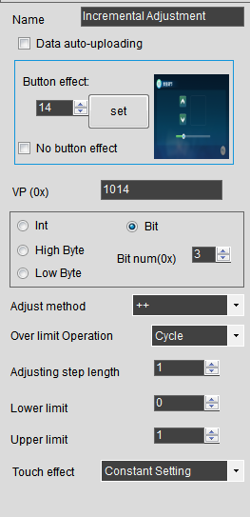

Instruction Explanation:

1: 06H, 10H is the standard command format.

2: 03H, 04H commands with and without clock, the standard format is without clock.

3: 03H, 04H With clock, 6 bytes of clock will be added before the check code after the returned data.

4: 03H, 04H The attached clock format is year, month, day, hour, minute, second (hex).

5: The read length of 01H, 02H instruction is fixed to 16bit.

6: The corresponding relationship between the address of the bit variable and the variable in the 01H, 02H, 05H instruction can be queried according to the above table.

**7: Modification of the default configuration**

Use such as UltraEdit-32 software to open DWINOS_DWIN_T5L_ModBusV2.bin

Find the first line of data (starting non-zero segment) and modify the marked position and download it.



Note: E000 means to edit the first entry from E000H (word address) 1C000 (byte address) of file No. 22.

FF00 : FF means maximum 255 entries 0x00 = configured as host, RTU data format.

0564 :Reissue the upper limit of the current command 5 times, 64=the delay time between commands is 100ms.

0140 :01 is configured as ID40 when the slave is configured, high 4bit=4 low 4bit=0, enable serial port 4, 8N1.

0A80H=2688 25804800/2688=9600 baud rate.

**Modbus communication example of Mitsubishi PLC as slave**

Add the following ladder line to the PLC to enable MODBUS

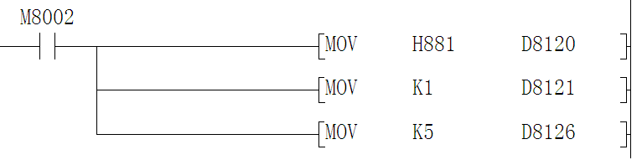

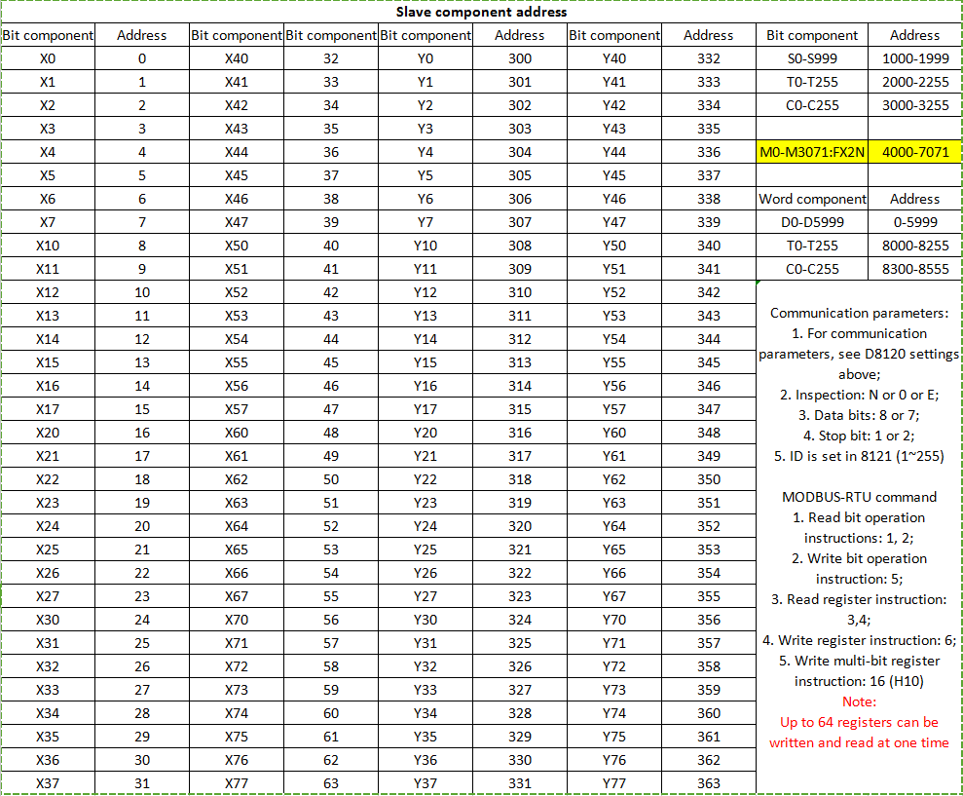

**Read PLC D100 to 0x1000 display on the screen (0x03 instruction)**

**File 22 is edited as:** 

Note: 0x5A= This instruction is executed.

0X01= PLC ID.

0X03=Use 03 command to read.

0x01=Read a word of data.

0x30=Communication timeout 48ms

0X01=Command trigger mode (execute on current page)

0x0000=Execute on page 0

0x1000=Display address

0x0064=The address allocated by D100 in the point table (100)

**Read PLC D10-D73 to 0x1002-1041 display on the screen (0x04 instruction)**

**File 22 is edited as:**



Note: 0x5A= This instruction is executed.

0X01= PLC ID.

0X04=Use 04 command to read.

0x40=Read 64 words of data.

0xA0=Communication timeout is 160ms.

0X01=Command trigger mode (execute on current page).

0x0001=Execute on page 1.

0x1002=Display address.

0x000A=The address (10) assigned by D10 in the point table.

**Write the 0x1042 address data of the screen to D1 of the PLC (0x06 instruction)**

**File 22 is edited as:**



Note: 0x5A= This instruction is executed.

0X01= PLC ID.

0X06=Write with 06 command.

0x01=06 instruction is limited to one word data.

0x30=Communication timeout is 48ms.

0X04=Command trigger mode (the data of 0x1042 is changed and sent automatically. This mode has a reissue function to ensure the success of the transmission, and there is no need to read the write result of the slave).

0x0000=No configuration required.

0x1042=The address allocated by the data source on the screen.

0x0001=The address (1) assigned by D1 in the point table.

**Write the 0x1044-0X1046 address data of the screen to D2-D4 of the PLC (0x10 instruction 04 trigger mode)**

**File 22 is edited as:**



Note: 0x5A= This instruction is executed.

0X01= PLC ID.

0X10=Write with 10 instructions.

0x03=Write 3 words of data.

0x30=Communication timeout is 48ms.

0X04=Command trigger mode (the data of 0x1044-0x1046 is changed and sent automatically. This mode has a reissue function to ensure that the sending is successful, and there is no need to read the write result of the slave).

0x0000=No configuration required.

0x1044=The address allocated by the data source on the screen.

0x0002=The address allocated by D2 in the point table (2-4).

**Write the 0x1047-0X1049 address data of the screen to D5-D7 of the PLC (0x10 instruction 02 trigger mode)**

**File 22 is edited as:**



Note: 0x5A= This instruction is executed.

0X01= PLC ID.

0X10=Write with 10 instructions.

0x03=Write 3 words of data.

0x30=Communication timeout is 48ms.

0X02=Command trigger mode (automatically sent when 0x1050 is non-zero, this mode has a reissue function to ensure that the transmission is successful, and there is no need to read the write result of the slave).

0x1050=The key address that triggers the sending.

0x1047=The address allocated by the data source on the screen.

0x0005=The address assigned by D5 in the point table (5-7).

**Read the Y1 of the PLC to the 0 bit display in the upper display area of the screen (0x01 instruction)**

Explanation: The screen has no bit address, in order to address bit variables, a 256bit display area is defined starting from 0X0100 .Since it is not a real bit variable, there are certain restrictions when using 0X01 and 0X02 instructions. 0x01, 0x02

The instruction is fixed to read 16bit (one word) data. When setting the slave bit address, press 16 to round up, as in this example Read Y1, find that the Y1 address is 301, the actual address of the slave machine should be 300, and read Y0-Y17 are all 300.Actually, from 300 to 315, all 16 bits will be read. The display location address is also rounded to 16, as in this example Displayed at bit 0, then bit0-Y0 of 0x0100 BIT1-Y1 .........BIT15-Y17.

If it is displayed in 16 bits, then bit0-Y0 BIT1-Y1 of 0x0101...BIT15-Y17.

The display area should be displayed with bit icons.

**File 22 is edited as:**



Note: 0x5A= This instruction is executed.

0X01= PLC ID.

0X01=Use 01 command to read.

0x01=Read a word of data.

0x30=Communication timeout 48ms

0X01=Command trigger mode (execute on current page)

0x0005=Execute on page 5

0x0000=Display bit address (0x0100.15-0x0100.0)

0x012C=The starting address of Y1 allocated in the point table (300)

**Read the PLC's M5 to the 32-bit display in the upper display area of the screen (0x02 instruction)**

**File 22 is edited as:**



Note: 0x5A= This instruction is executed.

0X01= PLC ID.

0X02=Use 02 command to read.

0x01=Read a word of data.

0x30=Communication timeout 48ms

0X01=Command trigger mode (execute on current page)

0x0005=Execute on page 5

0x0020=Display bit address (0x0102.15-0x0102.0)

0x0FA0=The starting bit address allocated by M2 in the point table (4000)

**Write the 5th bit of the keypad on the screen to Y2 of the PLC (0x05 instruction)**

**File 22 is edited as:**



Note: 0x5A= This instruction is executed.

0X01= PLC ID.

0X05=Write with 05 command.

0x01=One bit of data.

0x30=Communication timeout 48ms

0X04=Command trigger mode (the address of No. 5 bit is changed and sent)

0x0000=No configuration required

0x0005=Key bit address (0x0110.5)

0x012E=The starting bit address (302) assigned by Y2 in the point table.